**PL/SQL- Lab Task-I**

1. Write a PL/SQL program to check whether a number is even or odd by using IF END.
2. Write a PL/SQL program to check whether a given number is positive, negative or zero IF ELSE END IF.
3. Write a PL/SQL program to arrange the number of two variable in such a way that the small number will store in num_small variable and large number will store in num_large variable. (SWAPPING)
4. Write a program in PL/SQL to print 1st n numbers.
5. Find the output:

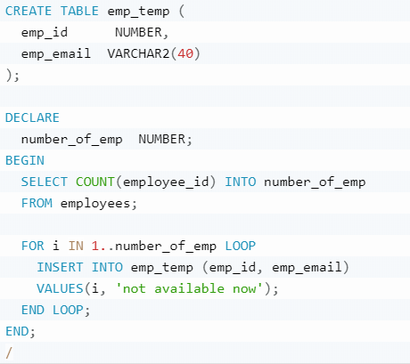

**Functions & stored Procedures- Lab Task-II**

**Question no. 1**

Create a Function to declare a variable, initialize it and then reverse that number and print it. For example, if number is 897 then it should print 798.

**Question no. 2**

Create a Function to check whether an initialized number is Armstrong or not.

**Question no. 3**

Create one procedure named minmax which display the lowest and the highest salary of employee (use emp_no as parameter) .Run the procedure to display the lowest and the highest salary.

**Question no. 4**

Create a package that contain two procedures (reverse, Armstrong) and one function (minmax).

**Question no. 5**

Create a procedure to display complete information of table employee having employee name contain “A” in their name and salary greater than 60,000.

**Note:** create **“employee”** table with specified attributes/columns and (insert) values in oracle 11g.

**Employee Table**

|  |  |  |  |  |
| --- | --- | --- | --- | --- |
| **emp_no** | **emp_name** | **d_name** | **address** | **salary** |
| 1 | John | CS | abc | 30000 |
| 2 | Tom | EE | xyz | 59000 |
| 3 | Harry | Mgm | uvw | 65990 |
| 4 | Henry | EE | iou | 98000 |
| 5 | Tim | CS | jkh | 56490 |

-----------------------------------------------------------------------------------------------------------------------------------

**Information:**

